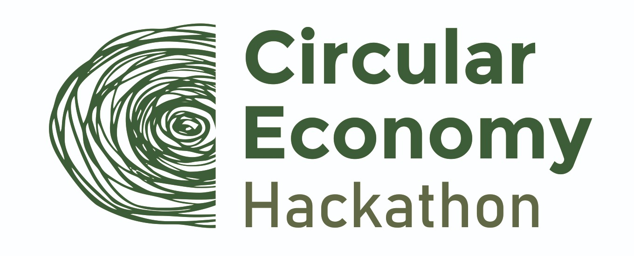

Are you ready for competition? - A circular systemic solutions hackathon for the ones who want to push the boundaries of cities in order to close the loops.

Location
Romania, Europe-wide (online event)

Date & time
11-12 June 2021

Format & platform/venue:
Online

Language:
English/Romanian

Application opening
1st of April

Background & purpose
Circular Economy Hackathon is a hack-and-learn race with the focus to unleash innovation. Participants will work collectively with the scope of developing ideas, involving students, recent graduates and PhD students in a process of designing and redesigning cities for circularity. The aim is to deep-dive and reveal the core problems with the current urban settlements. The event, which will be entirely online and will have an international purpose, aims to lead to the birth of innovative and entrepreneurial activities in 8 thematic macro-areas.
Hackathon is aimed at teams of students, recent graduates and PhD students from any university in Europe. We are looking for creative candidates who are passionate about the circular economy and who want to get involved. More information on requirements and procedures can be found in the Regulations. Candidates and their teams will have time to present their project ideas between June 11-12, 2021.
Participants will have the opportunity to develop and define their team's solution and present it to the panel of experts at the end of the second day. The jury will analyze the projects and nominate the winning teams for each challenge. Those who deserve it will then be rewarded by companies that promote the challenge.
Why should you participate?
- Meet fellow change-makers and inspiring people who might become your life-long friends or future business partners.
- Since circular economy is the future of sustainable businesses, you will learn how to get ahead in this field and solve real-life sustainability challenges.
- Develop creative ideas for sustainability working within an interdisciplinary team
- Challenge yourself, benefit from mentor’s experience during this themed event.
All participants will take their seats and focus on the following challenges, in which the challenges will be defined, due to the involvement of industry partners for each thematic area, as:
• Supporting innovation in products or business models to make consumer goods fully recyclable and / or reusable;
• Development of business models and projects to reduce food waste and recover surpluses;
• Promoting the circularity of construction materials and the construction of fully sustainable buildings;
• Promoting the transition to sustainable and clean energy;
• Encourage the design of circular cities from an architectural point of view;
• The inclusion of digital technologies as an element that allows the transition to circularity;
• Encouraging micromobility, sharing and dissemination of electric and sustainable vehicles;
• Promoting the development of technologies and processes that allow the collection and recovery of materials at the end of their life cycle.
The Circular Economy Hackathon will revolve around the 10 Rs of sustainable development: Refuse, Rethink/Redesign, Reuse, Repair, Reconstruction, Remanufacturing, Reconversion, Recycle, Regeneration, Recovery on all related challenges to be tackled.

Mentors
We want to involve the Romania universities, to apply and mentor students or teams of students in the Circular Economy Hackathon, more about application, participation and mentoring can be found in the rules of participation.

Outcome
3 champions will be given prizes amounting to 3000 euros after having participated in the 8 challenges across 2 days. Circular economy mentors will master participants and will provide guidelines, advices and support.

Target audience
- Romanian authorities responsible for circular economy
- Governmental officials
- Members of Parliament
- International organizations
- Key Romanian businesses
- Academia, research institutions
- Experts in the field
- Civil society
- Media representatives

Let’s take this challenge together and enjoy our urban circular living!

